**Semester: V Name of Student:**

**Academic Year: 2022-23 Student ID:**

**Class / Branch: TE IT**

**Subject: Advanced Devops Lab (ADL)**

**Name of Instructor: Prof. Manasi Choche**

**EXPERIMENT NO. 11**

**Aim: To understand AWS Lambda, its workflow, various functions and create your first Lambda functions using Python / Java / Nodejs.**

**Steps: First Lambda functions using Python**

**1. Open Aws Console and search for Lambda Service and open home screen of Lambda.**

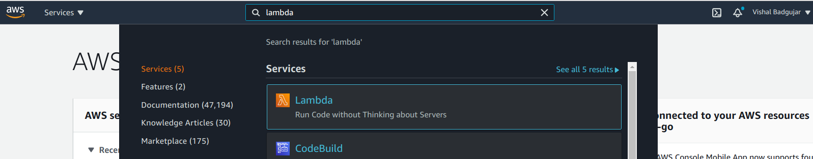

**2. Choose region in which you need to create Lambda function as it is region specific.**

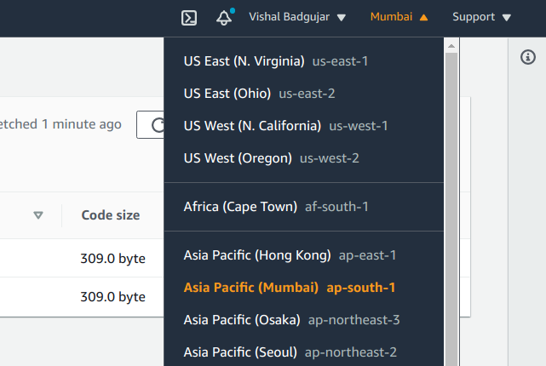

**3. Create sum as a Lambda Function in Python Language so select latest version of Python and choose role with basic Lambda Permission to allow cloudwatch for monitoring.**

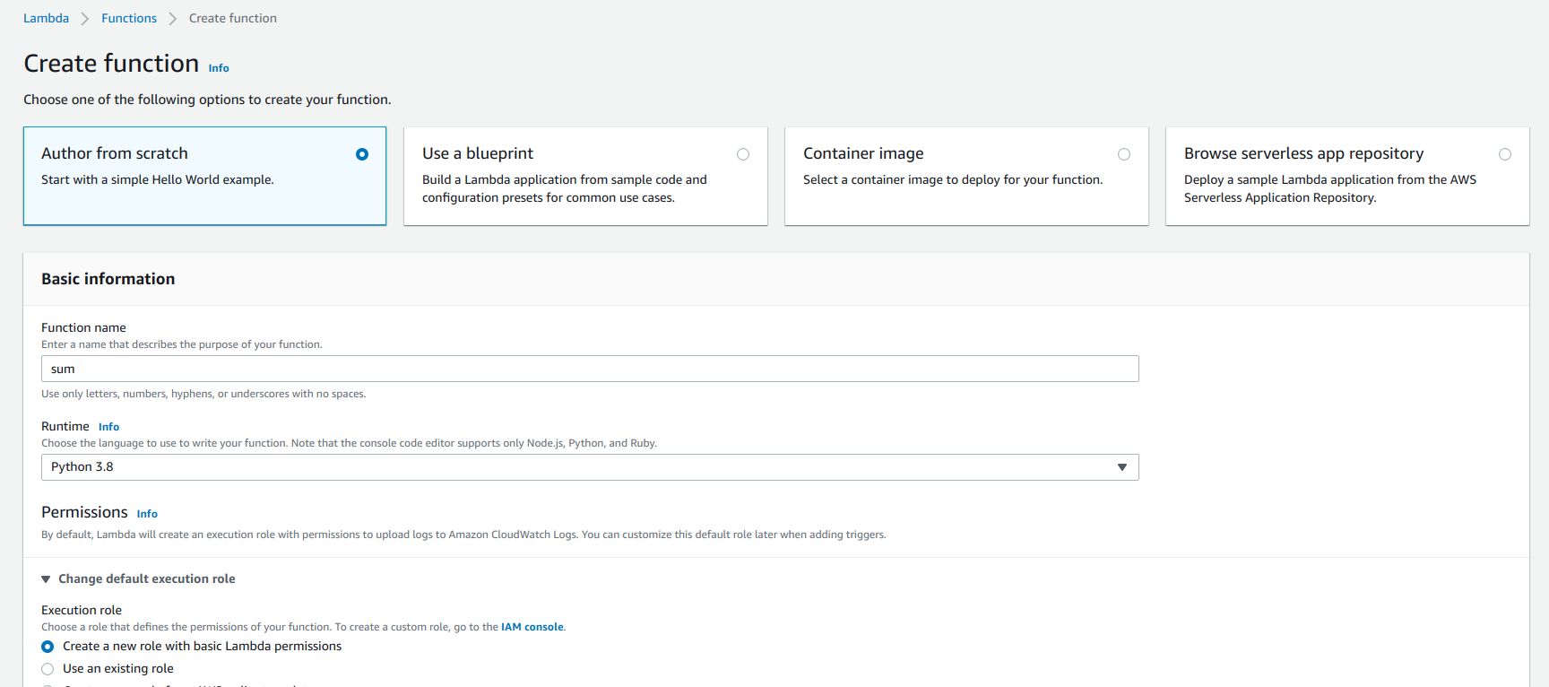

**4. Lambda sum function is created successfully**

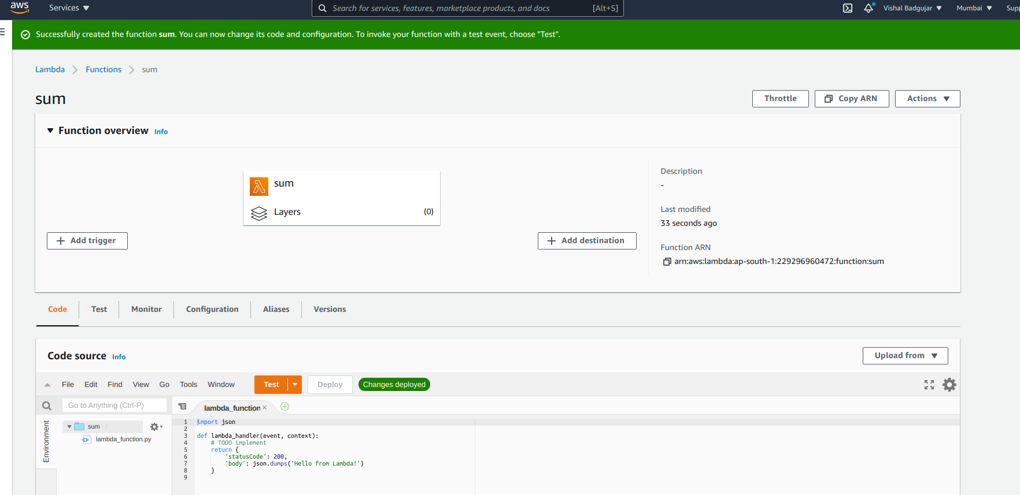

**5. Write a sample python code for sum of two numbers:**

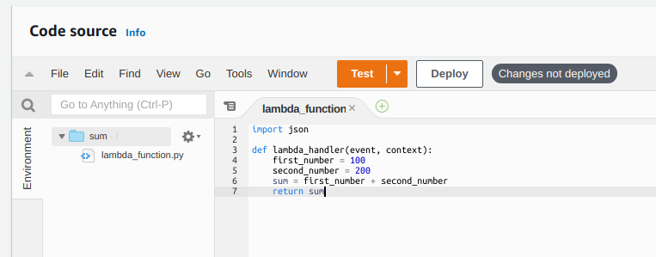

**6. Configure Test Event in Json Format**

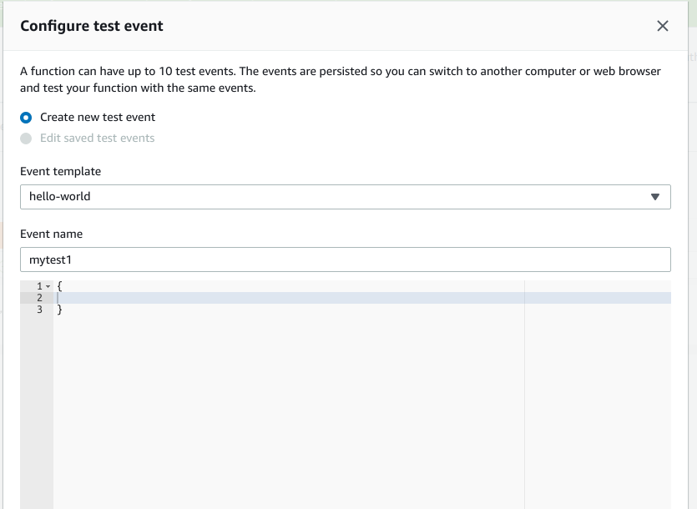

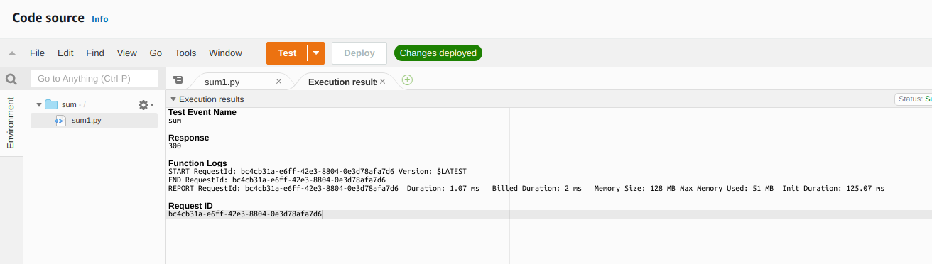

**Write a sample Second sample python Code:**

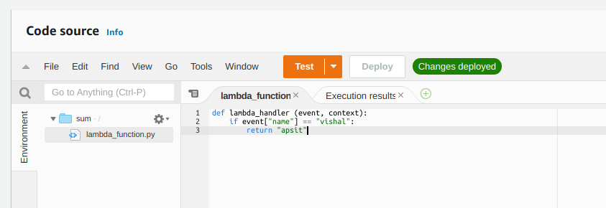

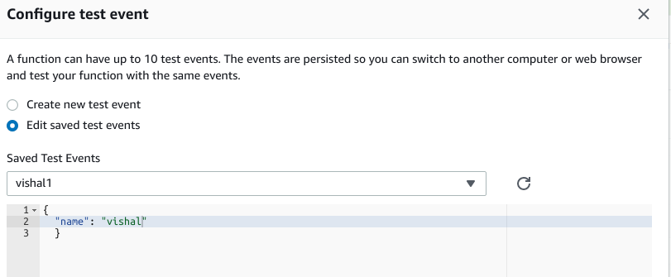Configure Test Event

**If condition met returns a value as apsit**

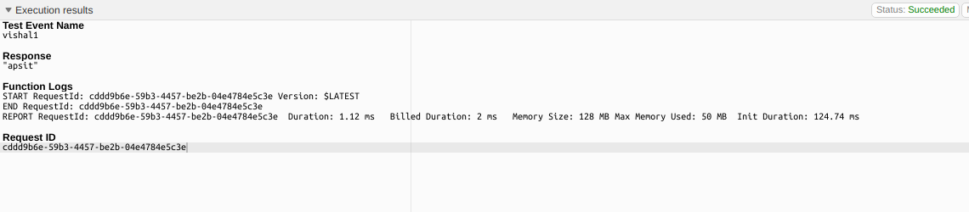

**Conclusion: Write your own findings.**